**Personal Portfolio**

(Group number - 118)

(Khrystel Santos – N9715045)

(https://github.com/ZacAtkinson/IFB299)

**Artefact 1** – (Regression Testing Plan)

(Description about what the artefact is in general)

The process or steps of testing changes to the development or sprint to ensure that they are working and no error occurs.

(Brief description of how it was used/contribution to the project)

Able to test all the development of the sprint 2 and to ensure that they are working correctly or to improve the specific project if failed.

(Screen capture of where it’s used)

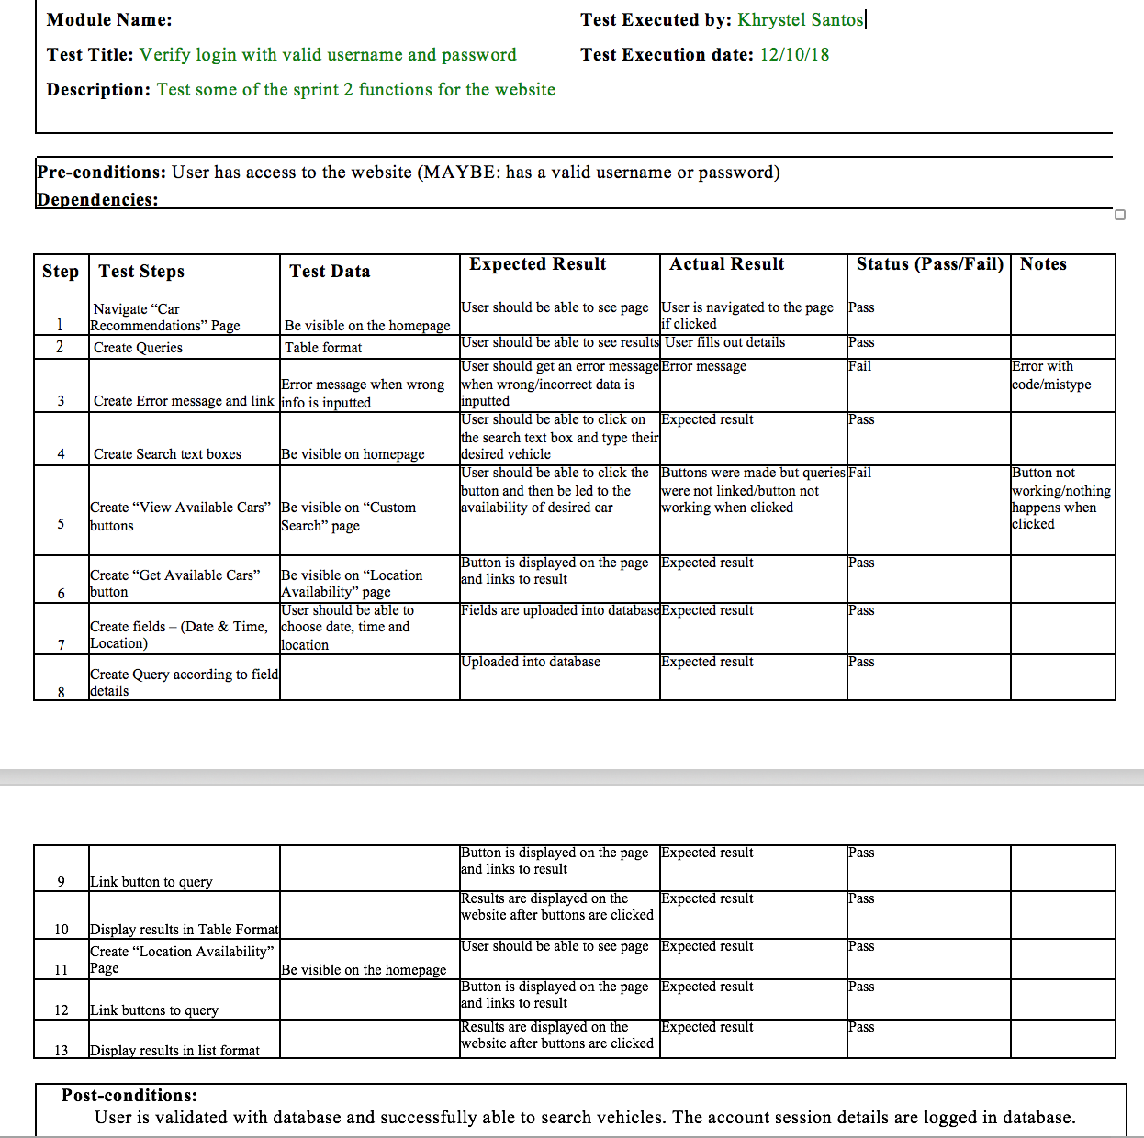

**Artefact 2** – (Written Test Cases)

(Description about what the artefact is in general)

Written test cases are conditions or a number of variables that should or was tested in order to justify whether the system testing satisfies the requirements or if they work correctly.

(Brief description of how it was used/contribution to the project)

Written test cases helped make sure that requirements were working properly in the project and also helped identify problems within the requirements and the design.

(Screen capture of where it’s used)

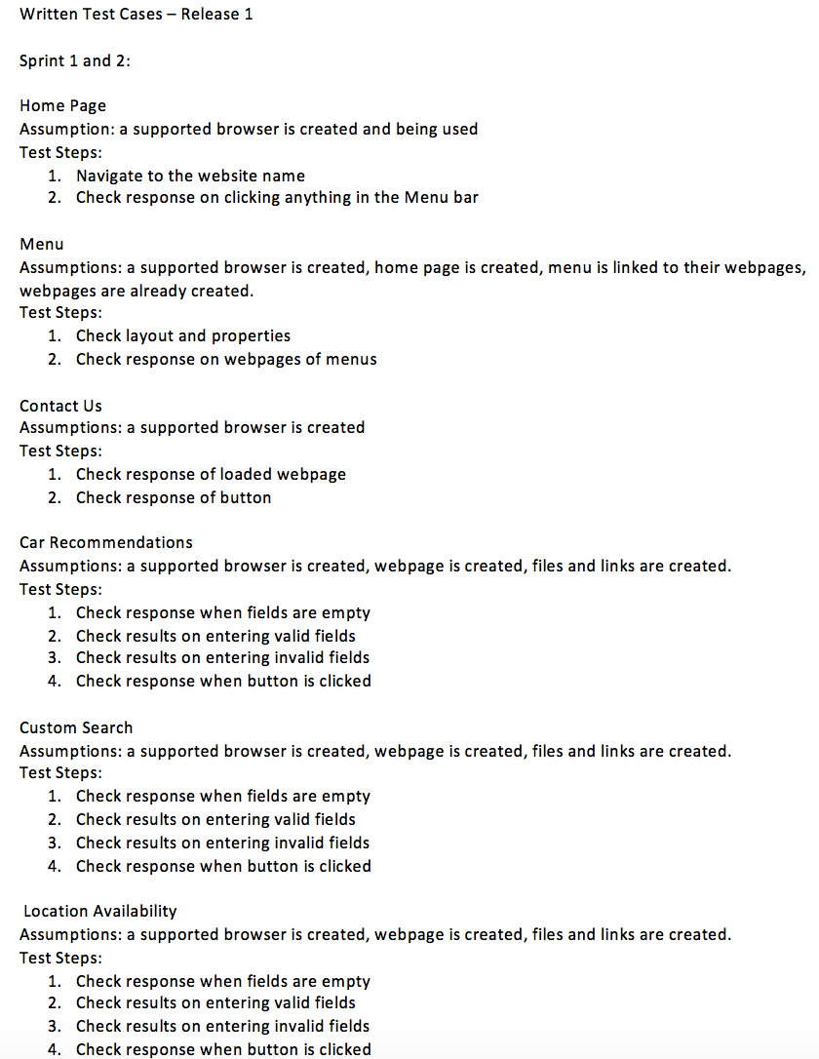

**Artefact 3** – (Provided details on the estimation methods)

(Description about what the artefact is in general)

Provides the breakdown of what work needs to be done in certain weeks, when meeting were held in those weeks, what work was done between CS and IS students, and deadlines were also set.

(Brief description of how it was used/contribution to the project)

Provided the group members deadlines of what work needs to be done in certain weeks in order to be up-to-date with the project. Provides a good breakdown of which group member has done what work. Provided us with dates of meetings and if meeting times were sufficient with the work that needed to be done for sprint 2.

(Screen capture of where it’s used)

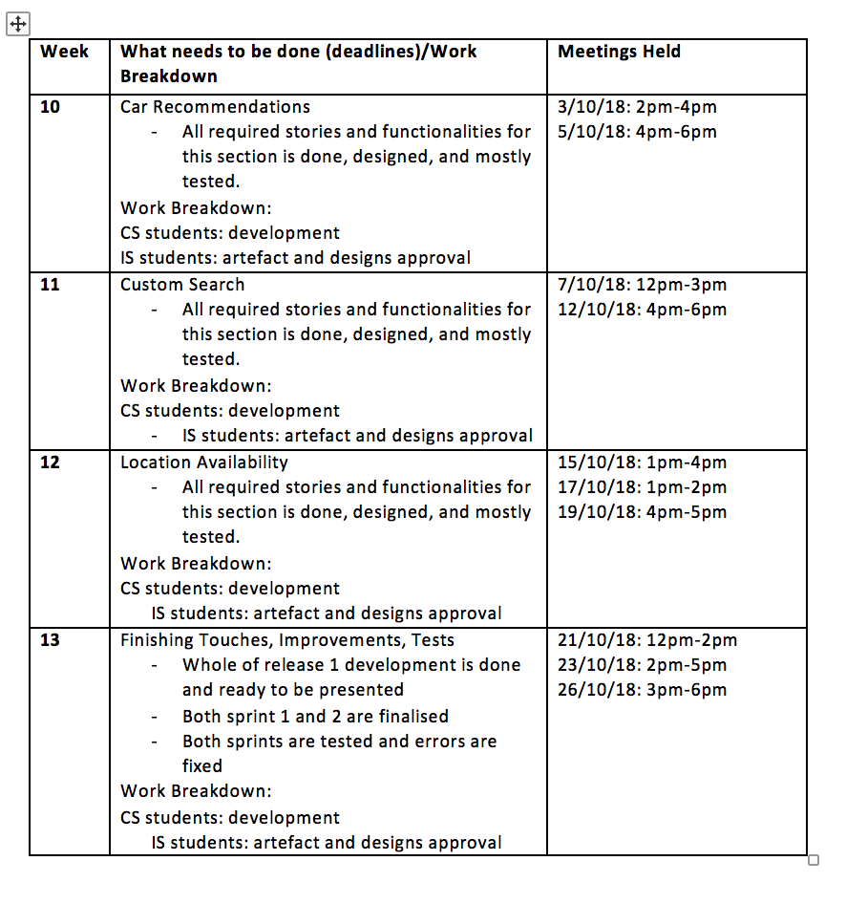

**Artefact 4** – (Class diagram)

(Description about what the artefact is in general)

Class diagram describes the structure of a system by showing the system’s classes, their attributes, operations, as well as the relationships among the requirements.

(Brief description of how it was used/contribution to the project)

Provided us a static structure of classifiers in a system. Helped us model requirements from business perspective. NOTE: Class diagram was done in Sprint 1, however, it was approved by the tutor that artefacts from sprint 1 that were not submitted from portfolio 1 can be included for portfolio 2.

**Zac Atkinson also did this artefact with me**

(Screen capture of where it’s used)

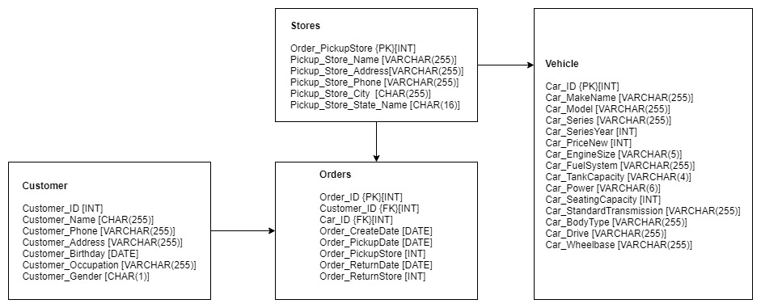

**Artefact 5** – (List of User Acceptance – Sprint 2)

(Description about what the artefact is in general)

Phase of the project development where the clients and developers tests the software in “real world” perspectives

(Brief description of how it was used/contribution to the project)

Gave us insights and ideas in relation to design, the importance of particular requirements, as well as the usefulness of the requirement. Also helped us determine whether it must be inputted in the project or development.

(Screen capture of where it’s used)

